***Programming in JAVA***

***Project-*** *Class Management System*

***Team 12-***

***Manisha Singh*** *19BCG10045*

***Abhijeet Chatterjee*** *19BCE10021*

***Ananya Singh*** *19BCE10177*

***Megha Bose*** *19BCE10338*

***Requirements***

***JAVA ==*** *8*

***JDK ==*** *15.0*

***MySQL ==*** *8.0*

***ODBC ==*** *8.0*

***JDBC ==*** *8.0.23*

***Database Credentials***

***Database ::*** *classes*

***Username ::*** *root*

***Password ::*** *root*

***UML Diagram***

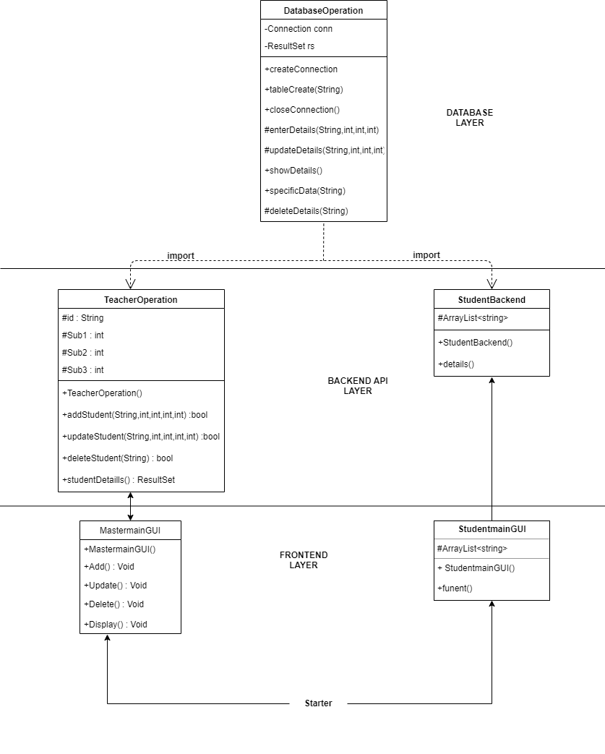

***Project Execution***

1. *Assuming all the requirements as specified above are installed in the system.*
2. *Then access the JDBCproject folder and go to the src folder and starter folder and run the starter.java file.*

***Project Screenshots***

